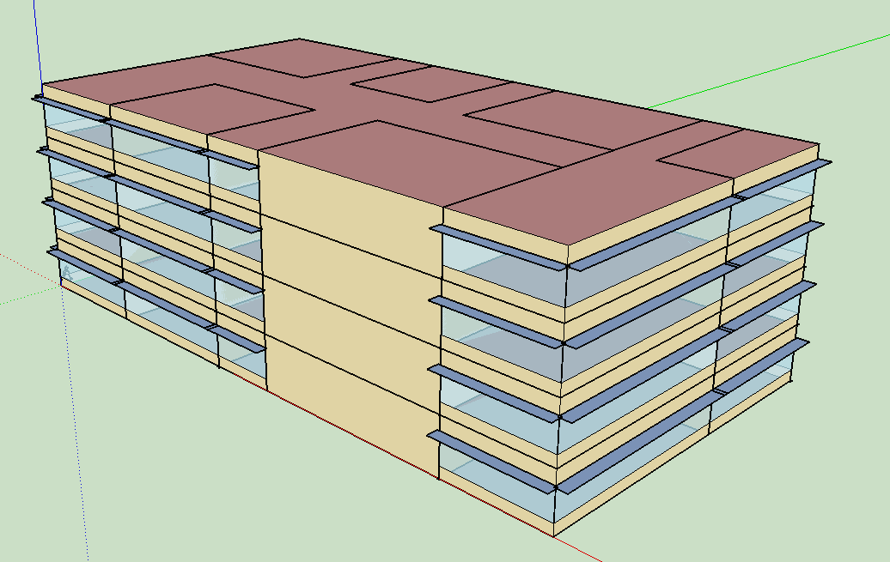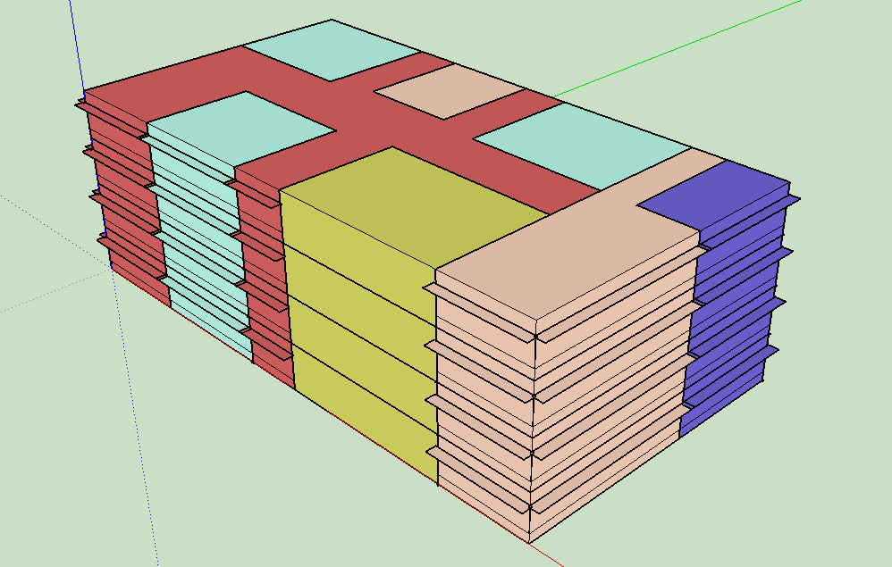  
  
This is a 48.00 x 25.00 x 16.00 [m] commercial building, aiming to be a new office for a company. It has 4 stories and each story is composed by:

- 3 separated closed offices;

- 1 break room;

- 1 restroom;

- 1 common corridor;

- 1 electrical/mechanical room;

- 1 space for the stairs.

Each type of space has been set with its own thermal zone, and the corresponding thermostats are in common for all the stories.

First, I’m going to simulate in Open Studio the behaviour of the building in 3 different locations around the world:  
1. Pisa ( Italy );  
2. Dakar ( Senegal );  
3. Yakutsk ( Russia );  
This first simulation is run using for walls and windows the sets which are given by default by Open Studio. Later on, I’m going to change them to see what happens.

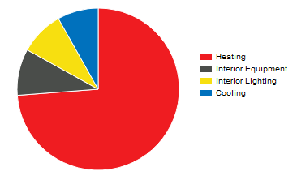In the first case, the main causes of consumption are estimated as reported in the following table:

|  |  |
| --- | --- |
| Heating | 924.03 [GJ] |
|
| Cooling | 102.14 [GJ] |
|
| Interior Lighting | 110.09 [GJ] |
|
| Interior Equipment | 116.06 [GJ] |
|

From these results one can see that in this case the consumption related to heating is predominant with respect to the other ones and the sum of the consumptions due to equipment and lighting makes a significant share ( almost 17 % ) of the total annual consumption. Instead, the consumption related to cooling is not so relevant, since the average temperature of the outdoor air in the considered year is not so high, even in the summer months.

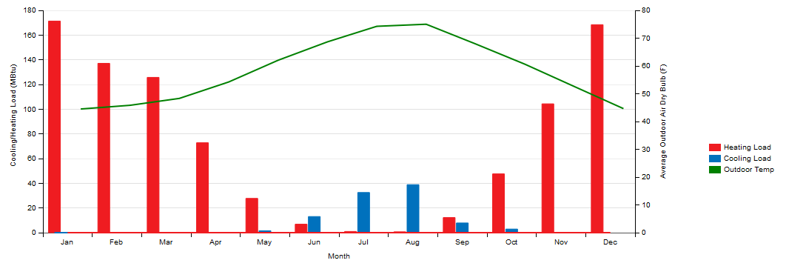

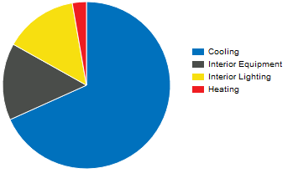If one considers Dakar instead, the results are expected to be much different:

|  |  |
| --- | --- |
| Heating | 21.15 [GJ] |
|
| Cooling | 531.33 [GJ] |
|
| Interior Lighting | 110.09 [GJ] |
|
| Interior Equipment | 116.06 [GJ] |
|

Since Dakar is in a very hot region, now the heating consumption is almost nil, while the cooling one becomes the most relevant. The consumptions related to interior lighting and equipment are the same as in Pisa, since they don’t depend on the outdoor conditions.

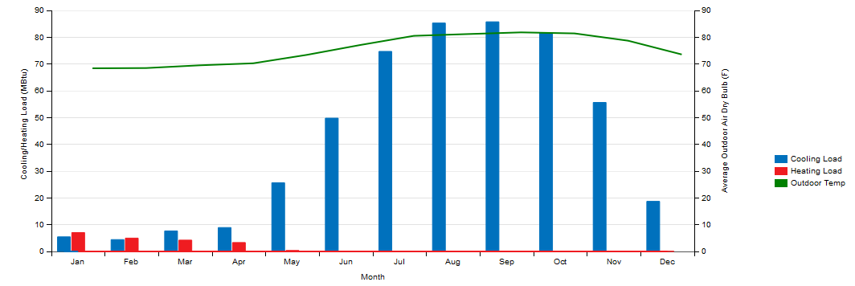

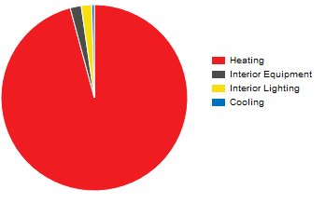Let’s now consider the case of Yakutsk, a city located in the East of Russia. Here one may expect a situation which is the opposite of the one of Dakar. The results are:

|  |  |
| --- | --- |
| Heating | 5798.51 [GJ] |
|
| Cooling | 26.32 [GJ] |
|
| Interior Lighting | 110.09 [GJ] |
|
| Interior Equipment | 116.06 [GJ] |
|

One can see that in this case almost all the consumption ( 96 % ) is related to heating, and this is mainly due to the extremely cold temperatures in this region. It’s also important to notice that in this case the total consumption is the highest one, considering all the different locations.

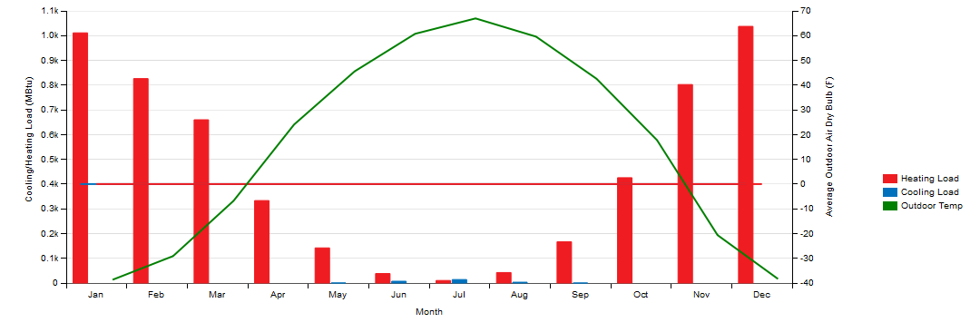

All these simulations have been run using the default structure of the wall for a closed office ( CZ 1 ) in Open Studio. This structure consists of:  
- 1 layer of *stucco*, 0.0253 meter thick;  
- 1 layer of *concrete*, 0.2033 meter thick;  
- 1 layer of *insulation*, 0.0337 meter thick;  
- 1 layer of *gypsum*, 0.0127 meter thick.

Let’s see now what happens if the walls structure is changed. I will run the simulation for the building, located in Pisa, using two different options:  
A. Exterior walls composed by ( from outdoor to indoor ):  
 - 1 layer of *stucco*, 0.03 meter thick;  
 - 1 layer of *concrete*, 0.2 meter thick;  
 - 1 layer of *insulation*, 0.3 meter thick;  
 - 1 *air gap* with thermal resistance of 0.18 [m2K/W];  
 - 1 layer of *acoustic tile*, 0.01 meter thick;  
 - 1 layer of *gypsum*, 0.02 meter thick.

B. Exterior walls composed by ( from outdoor to indoor ):  
 - 1 layer of *stucco*, 0.01 meter thick;  
 - 1 layer of *concrete*, 0.1 meter thick;  
 - 1 layer of *wood*, 0.04 meter thick;  
 - 1 layer of *gypsum*, 0.01 meter thick.

|  |  |
| --- | --- |
| Heating | 881.78 [GJ] |
|
| Cooling | 82.02 [GJ] |
|
| Interior Lighting | 110.09 [GJ] |
|
| Interior Equipment | 116.06 [GJ] |
|

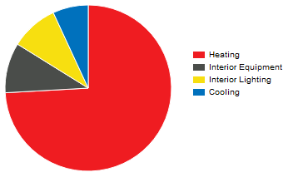In the first case the results are:

Comparing this output with the one of the base case, one can notice that the increase of the total thermal resistance of the walls results in a decrease of the heat exchanged through these and, consequently, in a decrease of the consumption for heating and cooling ( respectively of about 4.5 % and 19.6 % ).  
As far as lighting and equipment concerns, both are the same as in the base case, since these two shares are not affected by the energy exchanges with the external environment.  
In the second case, where a “bad” ( on a thermal resistance point of view ) walls structure is used, the results obtained are:

|  |  |
| --- | --- |
| Heating | 991.05 [GJ] |
|
| Cooling | 138.07 [GJ] |
|
| Interior Lighting | 110.09 [GJ] |
|
| Interior Equipment | 116.06 [GJ] |
|

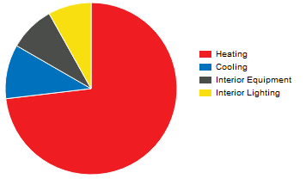

Comparing these results with the base case one can see that, as expected, the consumptions for heating and cooling are higher ( respectively of about 6.7 % and 26 % ), due to the worse heat transfers through the walls. If one considers the total annual consumption it is possible to state that, in case A it is reduced of almost 5 %, while in case B it increases of about 7.6 %. This results respectively in a decrease or increase of energy costs.

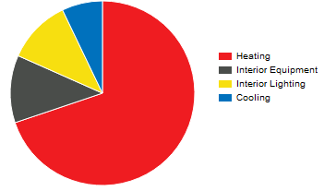It’s interesting to notice that even if one adopts a “good” wall’s structure or a “bad” one, the results in terms of energy consumption are not so different from the base case. This is probably due to the fact that in this building there is an huge window area, which is the real responsible of the heat losses.  
Let’s try to reduce this area, leaving the same building characteristics as in the base case ( location Pisa and default construction set ): now I’m setting a window to wall ratio equal to 0.2. The results obtained are:

|  |  |
| --- | --- |
| Heating | 684.67 [GJ] |
|
| Cooling | 69.82 [GJ] |
|
| Interior Lighting | 110.09 [GJ] |
|
| Interior Equipment | 116.06 [GJ] |
|

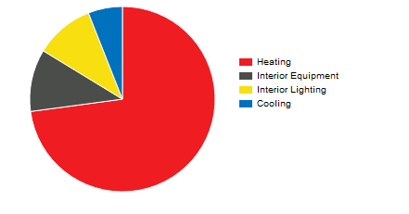It’s immediate to see how much windows affect the energy consumption for heating and cooling, which decrease respectively of almost 26 % and 31.6 %, with respect to the base case. The annual consumption decreases of almost 21.7 %, which results in a significant saving in the energy bill.  
Another way of varying the consumption working on the windows may be changing their type. Let’s consider the difference with the base case ( in which by default the windows were set as theoretical glass [167] ) when one use a double window composed by ( from outdoor to indoor ):  
 - 1 *theoretical glass [167]*;  
 - 1 *airgap filled with argon*, 0.005 meter thick;  
 - *1 theoretical glass [167]*.  
The results obtained are ( again considering Pisa as location and the default walls structure ) :

|  |  |
| --- | --- |
| Heating | 778.93 [GJ] |
|
| Cooling | 63.88 [GJ] |
|
| Interior Lighting | 110.09 [GJ] |
|
| Interior Equipment | 116.06 [GJ] |
|

One can see that just by adding another glass layer and a gap in between, the results are still significant, even compared to the ones obtained when the window to wall ratio is more than halved. The energy consumptions for heating and cooling decrease respectively of almost 15.7 % and 37.4 % with respect to the base case. The annual consumption decreases of almost 14.6 % with respect to the base case, and this fact may justify the higher expenses deriving from the adoption of the new type of window.

From these simulations one can conclude that changing the type of window is the first thing one can do in order to reduce the energy consumption of a building, without altering the original design of the building itself.   
In addition, comparing the results obtained for different locations, it is immediate to state that the worse the conditions of the environment in which the building is placed are, and the higher will be the amount of energy consumed by that building, in order to keep a comfort condition inside its envelope.